*Name-

*Date of Birth-

Email Address-

*Phone Number

Gender-

Ethnicity-

What can you bring to the patient group (Ideas/suggestions/comments-?

Privacy consent-

This form collects personal information and medical information about you. We use this information to allow the practice team to contact you. Please read our privacy Policy to discover how we protect and manage your submitted data.

I consent to the practice collecting and storing my data from this form.

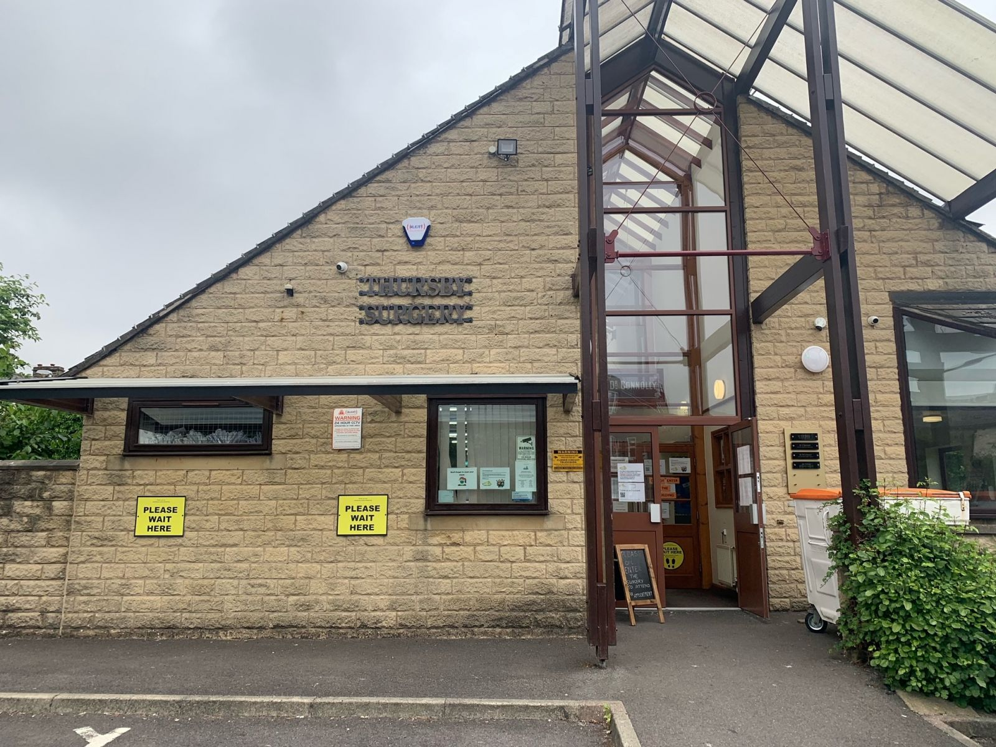

If you are interested in having a say in the way Thursby Surgery operates then by joining our patient participation group (PPG) is a great place to start.

**Aims-**

Set goals and agendas based on what the group thinks is important, using it as a platform to share important information and raise awareness for local issues.

We want to involve the community to work alongside the surgery and identify ways we can support each other and openly communicate.

We would like the group to be from all different walks of life to represent the community.

**Support-**

Your role will be supported, your contribution and your time will be valued by your community and your surgery.

If you are feeling nervous about attending the group alone, why not encourage a friend or family member to come along with you?

Tel: 01282 644330

**Thursby Surgery**

**Patient**

**Participation**

**Group**